AN EXPERIMENT
IN MACHINE TRANSLATION
W. P. LEHMANN
LIKE many linguistic activities, translation is poorly understood. Translators have concerned themselves with acquisition of the skill necessary to translate rather than with analysis, understanding, or a theory of the procedures involved. Even if they had developed a theory of translation, they have lacked objective means to test it. Consequently there are also no adequate statements about the bases involved in judging results. Moreover, views on translation have been confused by its use in the teaching of languages; students who have studied a second language in our schools have been required to translate. If the problem occurs to them subsequently, they are generally surprised to learn that unschooled bilinguals may be unable to translate. Studying languages has involved so much translating that it is wrongly assumed to be a natural linguistic activity. The behavior of bilinguals untrained in it suggests that it is not. Yet neither this behavior nor the use of translating as a pedagogical device has led to study of the procedures involved, let alone to a theory of translation.
Use of translating as a pedagogical device has, however, determined our views on adequacy of results. Texts selected to train students, whether Caesar's gallic war or expository material in a modern language, are generally translated for the gross meaning given by selection of words and grammatical patterns rather than for meaning carried by patterns of sound or the studied manipulation of language elements.

THE GRADUATE JOURNAL
If a student translates the opening line of Caesar's gallic war—Gallia est omnis divisa in partes tres—"All Gaul is divided into three parts," his instructor may inform him that he has done well by Caesar. The individual words of the English sentence match those of the Latin, as do the morphology and syntax. The instructor would object vigorously to an error in selecting lexical items—e.g. "two parts"—or to a grammatical form that didn't match—e.g. "will be divided." Yet the "translation" he accepts reproduces the sound poorly; it introduces a wretched rime which is not in Caesar's text and fails to follow Caesar's style. Our experience with translating in our schools has led us to the dubious conclusion that a translation is adequate if the gross meaning of words and grammatical patterns is transferred and no more than this.
Some translators, to be sure, have examined portions of their procedures, chiefly those translators who deal with literary texts. Yet their primary concern has had less to do with transferral of language patterns than with components of culture, such as literary conventions. This concern is also found in other groups, such as Bible societies, who focus on translations of words occupying special positions in our religious culture—god, virgin, word, holy and so on. Little attention, however, has been given to apparently neutral items of culture, such as world or earth. In interpreting some uses of world in translation of the Bible, such as Luke 2:1 which reports that Caesar Augustus had decreed a census of "all the world," readers silently exclude portions of our known world, such as North America or China; no one assumes that the world of Caesar Augustus included these unknown areas. But the "flood of waters upon the earth" in Noah's day is widely assumed to have encompassed the earth as we know it, even though the author of Genesis Chapters 7 and 8 must have had a more circumscribed view of the earth than did Luke. The arguments which often result are in great part caused by the mistaken conception of the use of language as manipulation of words and grammatical patterns, rather than as a means of communication within a circumscribed culture. Lacking a realistic view of language, translators have limited their concerns to helpful hints, comments on inadequacies, examination of some aims without analysis of the total set of procedures required for translation, to say nothing of an overall theory of translation. This was the context into which a machine was introduced which promised to simulate the craft of translating.

Since translators were not interested in analyzing the procedures involved in their craft and unreceptive to the machine, the early attempts at machine translation received no help from them and were crude. As suggested above, possibly the chief reason for their inadequacy was the generally poor understanding of language, even among those engaged in teaching it. Devotees of data-processing who undertook to develop procedures for machine translation understandably took over the widely held view that language consists of words, words, words. With the help of the computer they converted words, and obtained words, not language.
Yet their undertakings were not without result, for they demonstrated the need in translation of an understanding of language. Such understanding was the concern of linguists, though their insecure position in the academic world had almost buried their views. To a linguist language is a sign system which consists of various levels that include at least the following: a level of sound called phonology, of forms called syntax, and of meaning called semantics. Each level is composed of characteristic signs and orders. A multi-level system is highly complex, especially by contrast with our system of numerals. In the numeral system a sign always has the same value: 2 = 2 in the order of 32 as well as in the order of 23 or even 2.3. A simple example may illustrate the varying value of apparently the same sign in language at different levels.
At the phonological level, s must be distinguished from z in English, because it is used in contrast with z to distinguish meaning: the pronunciation /reys/, spelled race in our traditional orthography, has a totally different meaning from /reyz/, spelled raise; similarly cease, seize and so on. Accordingly at the phonological level s and z are two different signs in English. But at the syntactic level they are not. In making the plurals of nouns we select s or z in accordance with the preceding sound. If the preceding sound is p t or k, we select s, saying laps, rats, lacks. If the preceding sound is b d or g, we select z, saying labs, lads, lags. Since s and z are automatically determined at the syntactic level, at this level they are not different signs. Such uses of apparently the same elements led linguists to view language as consisting of various levels.
I am only concerned here with pointing out this complexity of language, and will neither give a more detailed account of the methods used for making the plurals of English nouns, nor of the various kinds of
THE GRADUATE JOURNAL
devices linguists have proposed to describe simply and yet thoroughly the complexity of language. In working towards an understanding of language linguists faced the dual obligation of describing the five thousand or more languages in use and of devising the theory necessary for such descriptions. Obviously neither obligation has been completely fulfilled. But it is clear that all languages consist of various levels. It is also clear that a language can only be understood by viewing it within its culture. If a kindly German grandmother says: "Ach Gott!" and we translate it: "Oh God!" rather than: "Oh dear!" or some other innocuous expression, we demonstrate our inadequate information about the use of German by its speakers. In our own culture newcomers may take some time to learn that our greeting: "How are you?" does not require a detailed response. For a total command of language we need to know its grammatical component, its component of meaning, and its manipulation by speakers. By one theory of language these have been referred to as its syntactic, semantic, and pragmatic components.
When we learn a language, we acquire some skill in each. Someone particularly adept, such as a poet, may be able to produce materials in which each is thoroughly controlled. For normal use we may not consider such control worth the trouble; language is so intricate that incomplete or even imperfect control of one component may not interfere with communication. Speakers of English, for example, have no prob-ems understanding a German who carries his own linguistic habits into English and pronounces the final consonants of labs, lads, lags like those of laps, rats, lacks; they may, however, find fault with the "foreign accent." Apart from such minor inadequacies, perfect specimens of lan-uage are rare; few users of language produce elegant materials like Shakespeare's, for example, with balanced control of phonology, syntax, and semantics.
If we set out to translate such elegant materials, we must transfer the text adequately at each level. On the other hand, a text imperfect at any level must be translated with comparable imperfections. For a text with adequate syntax, an accurate translation should reflect the lapses; a text in which meaning is confused, for example through malapropisms, should be so translated.
The ideal of reflecting an original text fully at the various levels obvi-ously makes translating difficult. Yet most materials that are translated are not elegant at all levels; anyone who has translated scientific texts has found that few scientists write as carefully as an Einstein, not to
speak of a Swift, let alone a Shakespeare. Translation of scientific and expository materials accordingly fulfills its purpose even when the result is plain; few of the translators who contract to provide translations of Russian materials at $32 per thousand words are given material of Pushkin or even Nabokov. Their output is acceptable, they receive their $32, even if their achievement at some of the levels of language is not elegant.
But in using computers to translate, even an understanding of language may not ensure adequate translation. Awareness of the capabilities of computers is also essential. Early attempts at machine translation incorporated procedures which demanded computer programs with virtually unlimited capabilities. They assumed that if understanding of the procedures of translation is inadequate, it could be improved by trial and error—and increasingly complex computer programs might be constructed to meet unforeseen difficulties. This optimism about the capabilities of computers and the malleability of computer programs turned out to be unfounded. As additional modifications in computer programs were made to handle additional patterns of language, the programs became so complex that they were uneconomical, even for restricted segments of language.
Much of the credit for handling the problem should go to government agencies. Some of them insisted early that machine translation would be successful only after translation, and language itself, were better understood; adequate computer programs might then be fashioned. The work which resulted led to the development of specialists in the field, and dealt with machine translation as one of the problems in applied linguistics. It also suggested that work on machine translation might be divided into three problems: the development of adequate computer programs; the analysis of language itself to secure adequate descriptions; study of the theory involved in producing such descriptions.
When computers first became generally available, programs were developed for the handling of numerical data; these programs, however, are far too simple to manipulate the complex sign system of language. Accordingly, special programs must be constructed of a complexity which few linguists have the capabilities to devise. In addition to their capacity, ideally the programs should be language-independent, so that the same system of programs may be used for any language whatsoever; for if a program were dependent on any one language, separate com-
puter programs would be required for each individual language. Further,
THE GRADUATE JOURNAL
programs must be devised in such a way that linguists may use them without understanding the operation of computers or computer programming. Such a system of programs, represented in Chart I, was developed in the Linguistics Research Center of The University of Texas under the direction of Eugene Pendergraft.
The sets of programs represented in the four rectangles above and below the central series of green rectangles prepare language material (text) and grammars for computer manipulation. Rectangle 1, request maintenance, ensures that all instructions given to corpus maintenance or grammar maintenance are without error. Rectangle 2, corpus maintenance, manages the language material that is to be processed. Rectangle 3, grammar maintenance, manages the grammars which linguists have devised for languages. These three sets of programs are ancillary; they ensure that only correct material is introduced into the computer.
Rectangle 4, transfer maintenance, has a somewhat different ancillary function. In translating, a special grammar is needed to make the transfer between any two languages. This transfer grammar varies with the languages being translated. If one translates Russian into English, highly detailed rules must be supplied for English articles. Russian has neither definite nor indefinite articles; unless a transfer grammar is devised to add articles, an English translation in which all articles are omitted is troublesome to many readers. Our reliance on articles may be demonstrated by omitting them from any English passage. On the other hand, in translating German, there are few problems with articles; relatively few nouns, like feminine names for countries (die Schweiz: Switzerland) , differ in their use of articles in English and German. A transfer grammar for German and English would therefore differ from one between Russian and English. Accordingly special transfer grammars to handle the differences between two languages must be devised, and maintained—like grammars of any individual language.
The heart of the translation program is illustrated in the set of central rectangles shown in green. The three rows of these represent the levels of language, to the extent they have been investigated. A text might be translated for its lexical items alone; for such translation the computer would be instructed to use only the first row of programs going across the chart. The resulting "word-for-word" translation would be difficult to follow unless the reader knew the input as well as the output language. It is virtually a minimum requirement to involve the first two rows, for
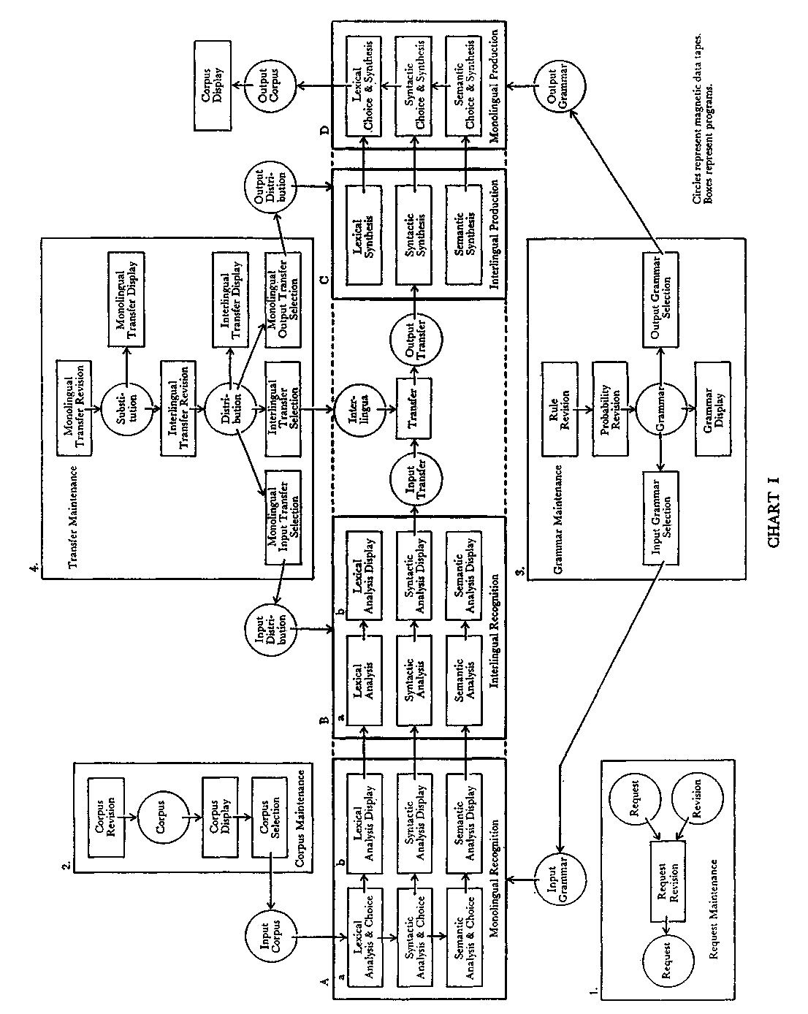

syntactic as well as lexical analysis. If the two top rows of programs in set A.a were used, they would analyze a text for its forms and syntax, as illustrated below in Chart III, In a German sequence, e.g. Alles, was wir beschreiben, A.a would identify wir as a pronoun with certain functions. To determine whether the identification had been done accurately, a display program A.b, is provided which prints out the computer's analysis up to this point. These intermediate displays are designed for research, and might be left unused when producing translation. Set
B, interlingual recognition, carries out analysis with reference to the
second language. Thereupon the two languages are matched and the
material is produced first with reference to the second language in Set
C. Finally it is produced only in the second language, Set D. The result
is put on a tape, and then printed out.
Both in securing satisfactory translations and in underwriting them, selection may be made among components. If aesthetic or financial considerations suggest restrictions, a cheaper, more rapid, less complete translation may be desired and produced. Obviously a translation at the lexical level alone would be crude. Such a translation of this German sequence might read: "All what we describe . . ." This sentence was selected as an illustration because of its simplicity; most sequences would be much more troublesome. Yet even a poor translation might be useful if large amounts of material needed to be screened rapidly and economically. But for linguistic research as well as for adequacy of result, fuller control of the language is desirable.
The Linguistics Research System is accordingly designed to provide flexible manipulation of language; the central set of programs reflects the structure of language as we understand it, and the remaining sets are ancillary.
A total understanding of language has unfortunately not yet been achieved; its achievement constitutes the second and possibly major problem for machine translation. The study of language as man's tool for communication is relatively new; in the nineteenth century, linguists attempted to gain an understanding of language through history. A descriptive approach, the study of language as a system of signs, engaged few linguists before the second decade of this century; only in the last two decades has the number of linguists who analyze language for its structure crept beyond a few hundred. Accordingly many problems remain before we can claim understanding of language. One of the chief
THE GRADUATE JOURNAL
attractions of machine translation is the impulse it provides for leading to that understanding. In general, the approach to language used in machine translation follows that achieved by structural linguists; the format of grammars used for computational purposes may, however, seem to differ from that of grammars used for the teaching of languages or other purposes.
This format, and the techniques which will adequately handle language and at the same time make it accessible to computers, are based largely on those developed by symbolic logicians. Their use has also led to a formalized approach to language known as mathematical linguistics. Investigations in the theory underlying mathematical linguistics constitutes the third problem of machine translation; this will be touched on only briefly here. Roughly, in mathematical linguistics the statements which are used to describe language are in turn subjected to analysis, as if they constituted an algebra. In this way they can be examined for characteristics such as their capabilities and their consistency, without the need to involve actual language material. The investigation of linguistic structures in mathematical linguistics has brought to the study of language the analytical power which has contributed to the developments in the physical and biological sciences; it promises similar achievements for the sciences dealing with man and his activities, including language. When languages are manipulated in accordance with the procedures of mathematical linguistics, the approach is now commonly referred to as computational linguistics.
In linguistics generally, a sentence is taken as the unit of language. Under analysis it is broken down into its components—in a procedure not unlike the sentence parsing of our schools. A simple example may be taken from the text discussed below, which is taken from an essay, The Physiological Basis of Consciousness, by Professor Hans Schaefer:
Alles, was wir beschreiben, sind Vorgänge. Everything that we describe consists of processes.
By the type of parsing used in our schools, this sentence may be broken down into ever-smaller segments, represented by the boxes and their labels in Chart II below. Anyone who has parsed sentences remembers the problems, both of analysis and of display; the analysis presented here is a simple one, which does not break the sentence down to stems and inflections.
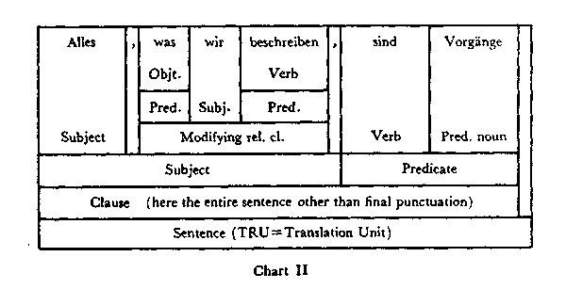
For precision and ease of manipulation, sentences are depicted in tree-diagrams, rather than in a series of boxes. Each branch of such a tree represents a sub-structure; each node a structure-point. The branchings may be restated as rules, as illustrated in Chart III, which gives the total set of rules for this sentence. Such rules may be stored in computers and manipulated by them. As part of this manipulation, the computer automatically assigns rule numbers like those given in Chart III. If the set of numbers listed there, from 785 to 10701, were given to the Linguistics Research System, the German sentences illustrated would be printed out by the computer.
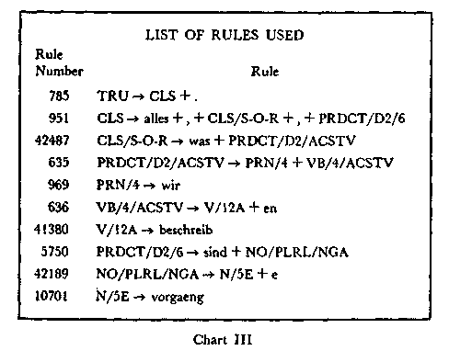
THE GRADUATE JOURNAL
To the extent that a description of a language is complete, a computer can reproduce genuine sentences in that language but the present descriptions are still quite inadequate. The inadequacies are sometimes strikingly illustrated in the sentences generated by computers. Such sentences have attracted the attention of literary figures, whose imagination is caught by the novel forms of expression emitted from the brute but honest computer. From Victor Yngve's description for computational purposes of the little engine that could, the times literary supplement (No. 3,258, 6 August 1964, p. 691), cited:
She is never cooled, and he is no longer painted.
He never makes hungry lists and the bright roofs below
her four wide chairs. Not only on a engine is he warm. What does she put four whistles beside heated rugs for.Q
Although these products of the computer may now seem amusing, if the descriptions of any language were complete, a computer would accept and produce only sentences which a native speaker of that language would permit.
The production of only authentic sentences would have various uses, one of them translation; another would be the automatic production of abstracts. For translation, descriptions of two languages are manipulated. In such manipulation descriptions are used which have been made previously by linguists, as illustrated above. Although the linguists use extant grammars and dictionaries, they must make new detailed descriptions, if only to conform to the requirements of computers. The grammar illustrated here was produced under the direction of Wayne Tosh of the Linguistics Research Center, who also provided the illustrative charts. The grammar used currently for German consists of 2,600 rules of syntax, 41,800 rules for lexical items and 6,200 for transfer; that for English consists of 800 rules of syntax, 76,200 for lexical items and 3,000 for transfer. In their production, the German grammar was based on technical texts for the most part published in journals; the English grammar was based on translations of these German texts.
For translation by machine, each rule in one language must be matched with one or more rules in the other. When, for example, the computer is asked to translate the sentence: Alles, was . . ., it searches its store of German materials for the various elements and their uses. Any element may be analyzed variously. If Alles were examined indi-

vidually, it might be interpreted as an adjective rather than a pronoun. But in the sequence within this sentence, this analysis would be discarded in favor of the one stated by rule 951, in which Alles is identified as a pronoun followed by a comma, a relative clause, another comma and a predicate. The next word was is in turn identified as a pronoun followed by a "predicate" requiring the accusative. Eventually the analysis given in Chart IV is achieved. This analysis is then processed in set B of the translation program, and matched with an English analysis similarly produced. If the matching is accurate and the analysis is complete, an accurate translation will result.
Adequacy of translation will depend on adequacy of analysis. At present, linguists have just begun to move beyond the syntactic level to the semantic. Machine translation to the present has therefore not gone beyond the syntactic level. Yet if a transfer grammar is produced which will equate the syntactic patterns of two languages, sentences in one language may be translated syntactically into the other. Such a translation was produced experimentally in the Linguistics Research Center early this year. A short German text was translated into English. In the segment of the translation which follows this article one can compare it with the original German, and with the English text which was translated earlier by human translators for preparation of the English description.
The experiment was of use to the various segments of the Linguistics Research Center. To the programmers it demonstrated that the various sets of programs which they had produced in the course of five years meshed successfully in processing German and English texts. Some sequences of the German text were not handled adequately; like some human competitors, the programs could not manage a prefix separated from its verb and put at the end of the clause. In the sequence: und drückt einen aktiven Anteil unseres Ich an der Auswahl aus der Summe möglicher Erfahrungen aus, it did not associate the final aus with drückt; failing the identification, it simply reproduced the German in its translation.
To the linguists it demonstrated the adequacy of their grammars. The sentence for which the rules were listed here, however, continued with a relative clause: die ihre Spur . .. The pronominal adjective ihre may refer to the third singular or the third plural pronoun; in the sentence here it refers to Vorgänge, and must accordingly be plural. The computer interpreted it to be singular.
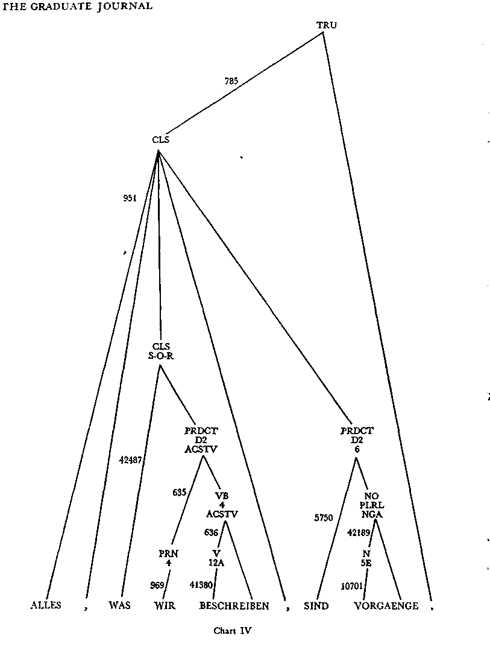

Though demonstrating in general the success of the Linguistics Research System and the adequacy of the grammars, the experiment was also valuable in pointing out areas that require additional work. Complete translation of a text would require control at its phonological and semantic levels, control for style, for cultural components and the like as well as for syntax. Such additional control will result from improvements in programming, in linguistic analysis, in theory. These improvements will increasingly engage the attention of various academic groups, from engineers through mathematicians to philosophers besides the linguists and computer specialists themselves.
The translation illustrated here was achieved by the work of a small group over the past five years. Various developments suggest that with further computer manipulation of language, machine translation will be greatly improved over the next five years. Among these are the vast advances in computers themselves. Rapid access to large amounts of stored data will speed up experimentation as well as output; the possibility of using scopes to modify data stored in the computer will permit linguists to improve their analyses rapidly without waiting for the cumbersome and costly printouts they now receive. But possibly even more important, complex programs are now available to handle linguistic material; among other capabilities, these will permit automatic analysis of texts, eliminating some of the drudgery involved in the manipulation of language. Further, in place of the logicians, mathematicians or linguists who were competent in one of the fields involved in computer manipulation of language, specialists are now being trained in those areas of these fields which are pertinent for computer manipulation of language.
We may look forward then to rapid development in our understanding of language. The possibility of handling large amounts of language data rigorously has already had an effect on syntactic and semantic theory. Yet a broad area of research is open to students of language and computation; language learners with a scientific bent may come to find an interest in research in language rather than in it as a tool for keeping up with publication. As this research expands, specialists from ever more fields will become involved, including neurologists who may inform us how the brain stores and manipulates language. Even before then the means will be provided to bring under control the tremendous amount of publication which is now often inaccessible because of its bulk and of the varieties of language used by man.
It is not unlikely that language science will finally separate itself from the broader complex that was once called language arts. Thus philology and linguistics, with their subdivisions of morphology, semantics, historical and comparative grammar, and so forth, which effectively employ both empirical and theoretic methods of research, would receive logical recognition of their particular character. Whether they can then still lay claim to membership in the humanistic disciplines or whether they will lead an autonomous and lone existence like mathematics, is a question that will be answered fifty years from now.
—Gustave O. Arlt
TRANSLATION: HUMAN AND MACHINE
Paragraphs from the German text, human translation, and machine translation are alternated. The left-hand numbers indicate the same line in each of the three texts.
Corpus Display Input Text
74001001 Die koerperlichen Bedingungen, unter denen allein Bewusstsein
- moeglich ist, sind recht mannigfaltig, das Problem der Kopplung
- von Psychischem an die Struktur unseres Gehirns so verzweigt, dass
- in einem Aufsatz nur ein Teilproblem herausgegriffen werden kann.
- Was hier behandelt werden soll, stellt das (wie ich glaube)
- wesentlichste Problem einer koerperlichen Bedingtheit
- seelischer Vorgaenge dar.
74001008
Corpus Display Human Translation
74001001 The only bodily conditions under which consciousness is possible
- are quite diverse and the problem of connecting the psychic with
- the structure of our brain is so complex that in an essay one can
- only select a partial problem. The subject to be considered here
- represents (in my opinion) the most essential problem of a
- dependence of mental processes on the body.
74001007
Final Display Machine Translation
74001001 The only bodily conditions under which consciousness is
- possible are quite diverse and the problem of connecting the
- psychic with the structure of our brain is so complex that in an
- essay one can only select a partial problem. The subject to be
- considered here represents (in my opinion) the most essential
- problem of a physical dependence of mental processes.

THE GRADUATE JOURNAL
74002001 /
74002002 Der Zustand, den das Gehirn des Lesers in diesem Augenblick
74002003 auf weist, wo er sich entschlossen hat, ein so kompliziertes Thema
74002004 mit dem Verfasser gemeinsam zu betrachten, ist der einer wachen
- Aufmerksamkeit. In ihm d. h. in demjenigen Teil seiner Person,
- den er sein "Ich" und der seiner Selbstbeobachtung in dies
- em Moment offenliegt, findet er jetzt eine Reihe von Ueberlegungen
- vor, die teils mit dem gleich sind, was der Verfasser zur Zeit der
- Abfassung dieses Aufsatzes auch ueberlegte. Teils weichen seine
74002010 Gedanken von denen des Verfassers ein wenig ab, was allein dadurch
74002011 verstaendlich ist, dass der Verfasser diese Gedanken produzierte,
74002012 im uebrigen auch fuer richtig haelt, der Leser dagegen der
74002013 "Nachdenkende," weil Empfangende ist und dabei hoffentlich
74002014 nicht ganz den Zwang loswird, beim Nachdenken das, was ihm gesagt
74002015 wird, auf seine "Richtigkeit" zu ueberpruefen.
74002016

74002001 I.
74002002 The condition of the reader's brain at this moment when he has
- decided to consider with the author such a complicated subject is
- that of wakeful attentiveness. In it, i.e. in that part of his
- person which he calls his "ego" and which at this moment is
- open to his self-observation, he now discovers a series of
- reflections, which are partly identical with the author's
- reflections at the time this essay was written. Partly, his
- thoughts differ a little from the author's, which is
- understandable merely through the fact that the author produced
- these thoughts, and furthermore considers them correct, while the
- reader is the receiving party and therefore the "meditator,"
- and, hopefully, does not in the process lose the compulsion to
- examine what he is being told as to its correctness.
74002015
74002001 I The condition of the reader's brain at this moment when it
- has decided to consider with the author such a complicated
- subject is that of wakeful attentiveness. In it, i.e. in that
- part of its person which it calls its "ego" and which at this
EINE ART EXPERIMENT
- moment is open to its self-observation, it now discovers a series
- of reflections, which are partly identical with the author's
- reflections at the time when this essay was written. Partly, its
- thoughts differ a little from the author's, which is
- understandable merely through the fact that the author produced
- these thoughts, and furthermore considers them correct, while the
- reader is the receiving party and therefore the "meditator,"
- and, hopefully, does not in the process lose the compulsion to
- examine what he is being told as to its correctness.
74003001 Alles das aber laeuft im Leser als "Bewusstsein" ab, also
- dort, wo "er selbst" zu Hause ist. Was Bewusstsein ist, kann
- man nicht naeher umschreiben. Es gibt keine Beschreibungsmittel
- fuer etwas, das selber einer jeden Beschreibung aller Dinge
- vorausgeht. Alles, was wir beschreiben, sind Vorgaenge, die ihre
- Spur vorher in unser Bewusstsein eingegraben haben.
74003007
74003001 All this, however, proceeds in the reader as "consciousness,''
- i.e. in that area where "he himself" is at home. What
- consciousness is, one cannot further circumscribe. There is no
- means of description for something which itself precedes any
- description of all things. Everything we describe consists of
- processes which have first engraved their traces in our
- consciousness.
74003008
74003001 All this, however, proceeds in the reader as
74003002 "consciousness," i.e. in that area where "he himself" is
- at home. What consciousness is, one cannot further
- circumscribe. There is no means of description for something
- which itself precedes any description of all things. Everything
- we describe consists of processes which have first engraved its
- traces in our consciousness.

